# **Instructions to setup GhostQA using.bat file**

**Step 1-: Need to provide framework code for Core application referent and to generate the published file for UI and API**

**Step 2-: Install IIS on the machine using the below guide.**

###### Installing Internet Information Services (IIS)

To install Internet Information Services (IIS), follow the steps below:

1. Start > Control Panel > Programs and Features

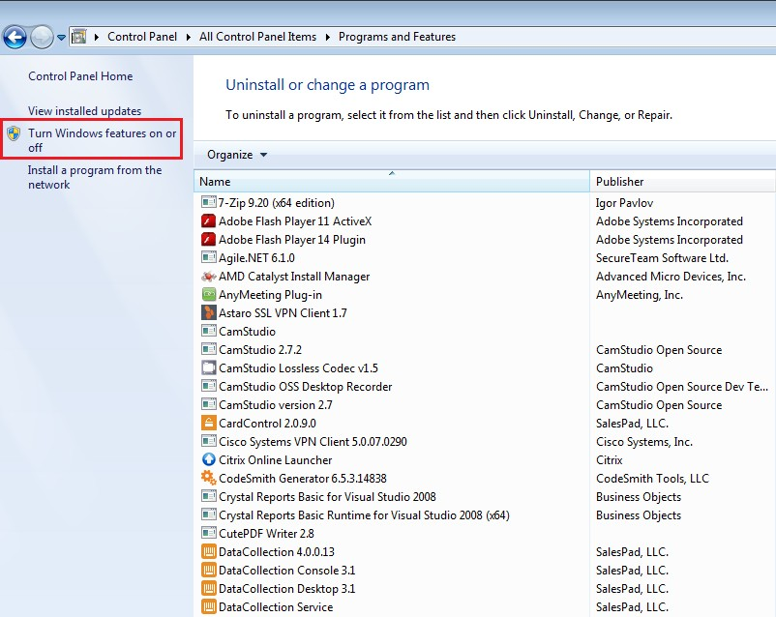

1. Click Turn Windows features on or off. The Windows Features window will appear.
2. Ensure all features under Internet Information Services and Microsoft .NET Framework are selected.

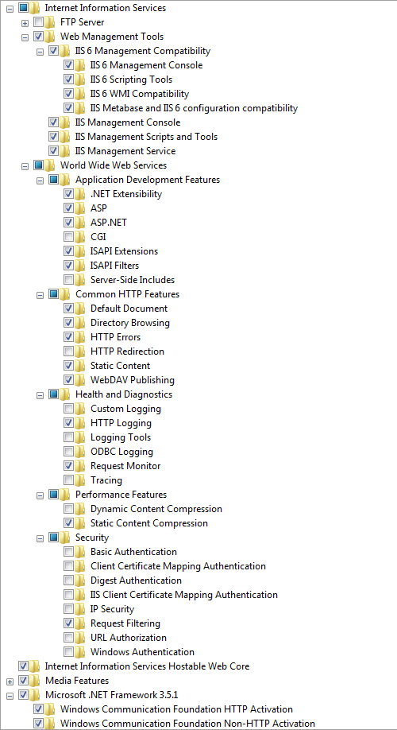

1. Click **OK**to install selected Windows components, including IIS.
2. To access IIS, click the Windows **Start**button. The Start menu/screen appears. Start typing Internet Information Services Manager in the search field and click the Internet Information Services (IIS) Manager once it appears.

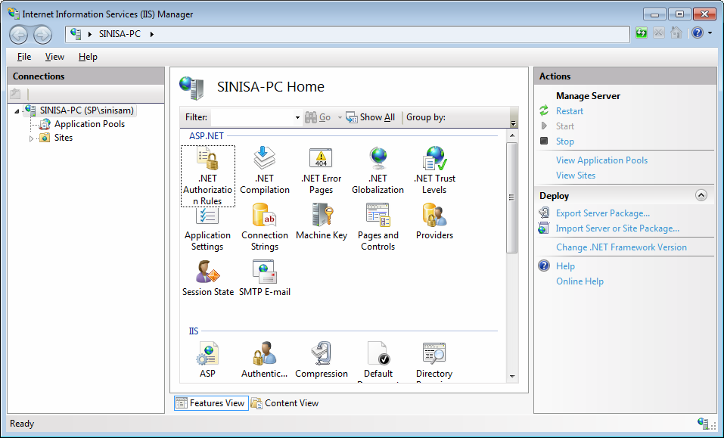

1. Need to install re-write URL module 2.1  
   [**https://www.iis.net/downloads/microsoft/url-rewrite**](https://www.iis.net/downloads/microsoft/url-rewrite)
2. Need to install .NET Core Hosting Bundle Search over Chrome / any web browser and install

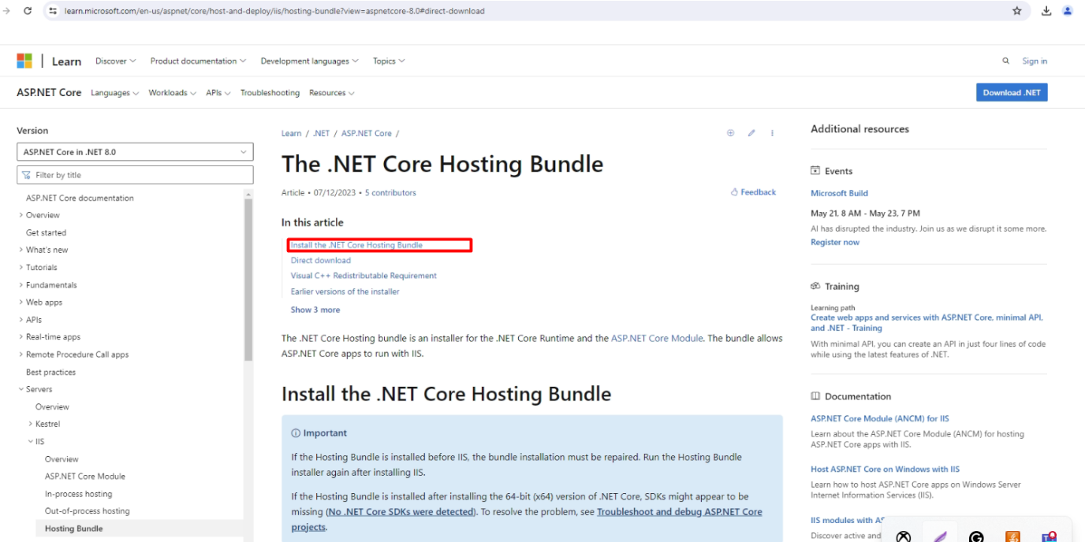  
[**https://learn.microsoft.com/en-us/aspnet/core/host-and-deploy/iis/hosting-bundle?view=aspnetcore-8.0#direct-download**](https://learn.microsoft.com/en-us/aspnet/core/host-and-deploy/iis/hosting-bundle?view=aspnetcore-8.0#direct-download)

1. After installation of IIS make sure we have all permission for **IUser** & **IISUser** for that specific folder with the published project file where we have our published folder.

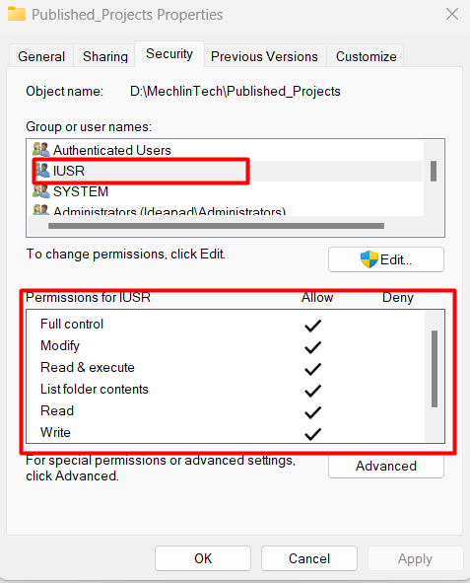

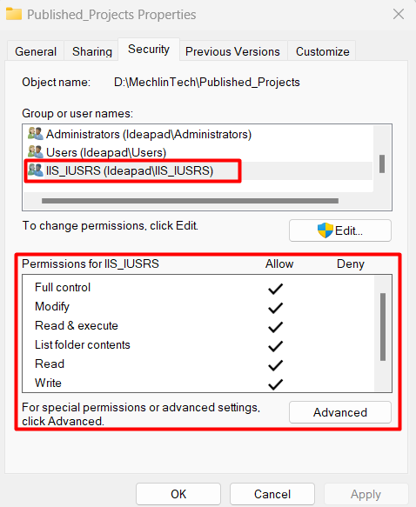

1. Here we have to extract one file in the **C:** directory so it will work with recording
   1. Here is the file download link by which we can download and extract it in the **C:** drive   
      [Download FFmpeg](https://ffmpeg.org/download.html)

**Step 3-: Install SQL Server using the below guide with Mixed Mode Authentication**

<https://www.bu.edu/csmet/files/2021/02/SQL-Server-2019-Installation-Guide.pdf>

1. After installation of SQL Server needs to work on below things

Create the Database using the database name  
Run the Script to create tables using the script below



Run the other script for creating procedures using the below script



Run one more script on the database for the initial user setup



Run the above script in the same order as mentioned above

**Step 4-: Download the provided zip file for GhostQA application setup**

1. **Put the files like** 
   1. **GhostQA_API**
   2. **GhostQA_UI**
   3. **SetupApp.bat**



**Into a published folder where we have all admin access**

**Right-click on the SetupApp.bat file and run as Admin**

**It will create two sites on IIS one for API and another for UI**

**Step 5-: Setup application**

1. **Need to change in appseting.json regarding the connection string**
2. The connection string will use a **username and password**
3. Create all required folders which are mentioned in **appsetting.json**
4. Create a **Data** folder in **GhostQA_UI/Images** folder of the published application
5. Create a folder in **GhostQA_API** of the published folder with the name **UploadedLogo**

Now we are ready to run our application using our IP address and port visible during bat file running in the command prompt

Once we are able to login into GhostQA Application need to setup **Browser, Application, Environment, and user in Settings section**

**We have to execute the inbuilt test suite at least once to proceed with GhostQA custom test suite feature**